**ViennaRNA Help and User Guide**

The following guide is available for use, to assist users with the ViennaRNA GUI

developed and distributed for free use under MIT licensing agreement. The following table of

contents below will link you through the document or it can be searched using the search bar

by pressing (Ctrl + F).

**Table of Contents**

**Downloading and installation guide** **2**

**Splash Screen** **4**

**Help Document/User Guide** **5**

**ViennaRNA GUI Programs:**

**RNAfold** **6**

**RNAalifold** **8**

**RNAplfold** **9**

**RNAcofold** **10**

# 

# Downloading and installation guide

A zip file containing all of the packages required for installation is on our Github. The user can download the zip file from <https://github.com/christopherota/ViennaGUIv2.0> . Once the zip file is downloaded, the user can extract it to their chosen directory.

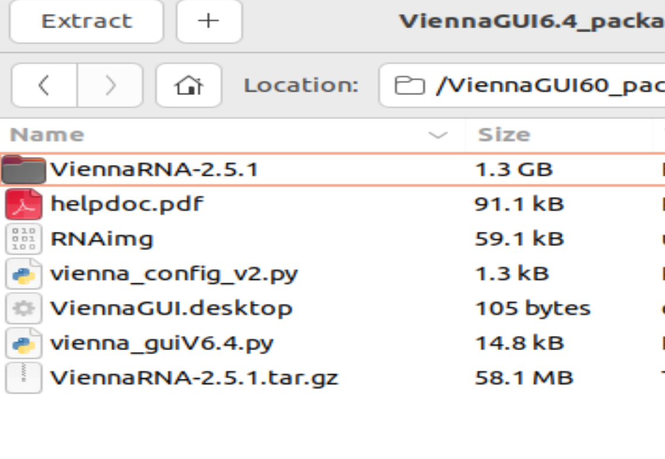

Once the package is installed can run the program via the command line prompt: ‘Python3 vienna_guiV6.4.py’

For more convenience, a user can choose to use the ViennaGUI.desktop file to quickly open the program without using the command line. If for some reason the desktop file does not run, the user can change the exec line in the text file to from the relative file path to the local file path of their directory, seen below:

Local Path:

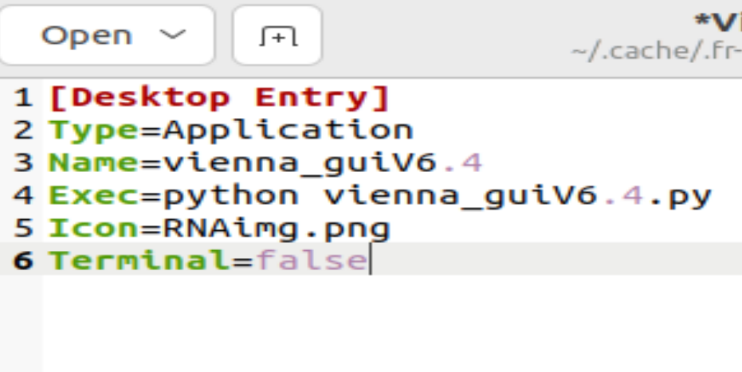

Relative Path:

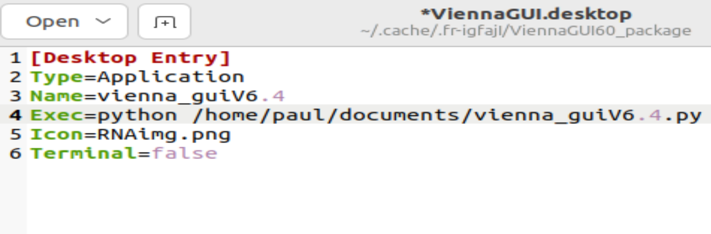

# Splash Screen

The splash screen is generated after execution of the GUI file. The screen seen below contains an image and label for the GUI program, along with a loading bar and output box for initial process checks. The loading bar will load for approximately 5 to 10 seconds in order to indicate the program is running properly. The output box will display status for process checks pertaining to the presence of ViennaRNA program executable files, ghostscript software, and a temp directory. In the absence of a temporary directory a file directory will be generated to store temporary files, this directory will be cleared after the GUI is closed and will have to be initiated again once GUI is rerun.

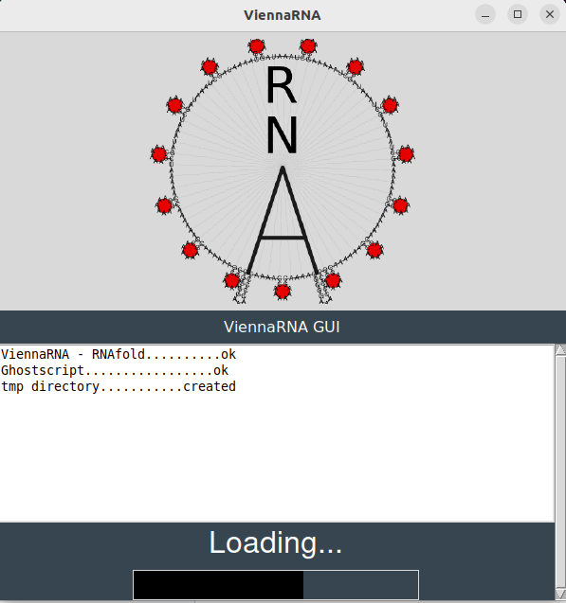

# Help Document/User Guide

This help document is stored in the same directory as the GUI program files. It can be accessed either through the GUI with the help button seen in the upper left corner seen below, or in the GUI file directory where the GUI files have been saved.

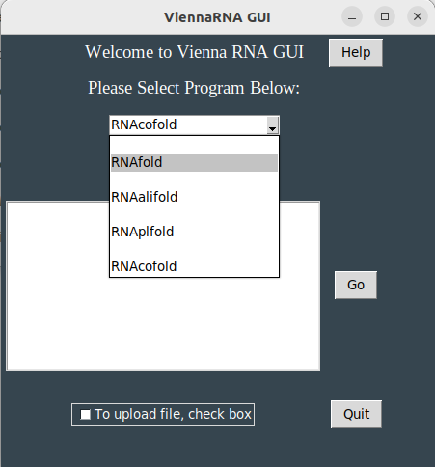

# RNAfold

RNAfold is a program part of the ViennaRNA suite which is used to calculate minimum free energy of predicted secondary structure of RNA sequences. The program can be selected from the dropdown menu seen below, and requires either pasting the sequence or by uploading a file containing the sequence of interest. In order to upload a sequence the check box at the bottom of the window must be checked to open a file selection tool and the file can be selected for use. Once either the file is selected or the file pasted select go to execute the program. Make sure to remove any text in text box if uploading a file.

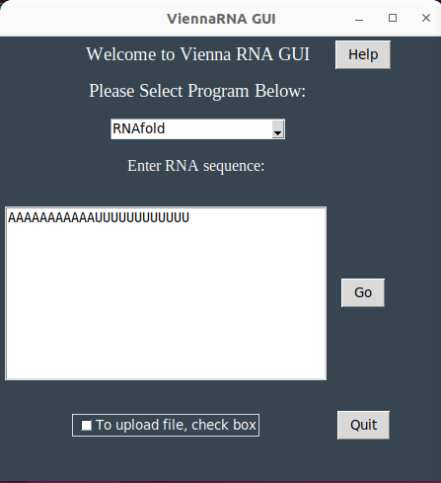

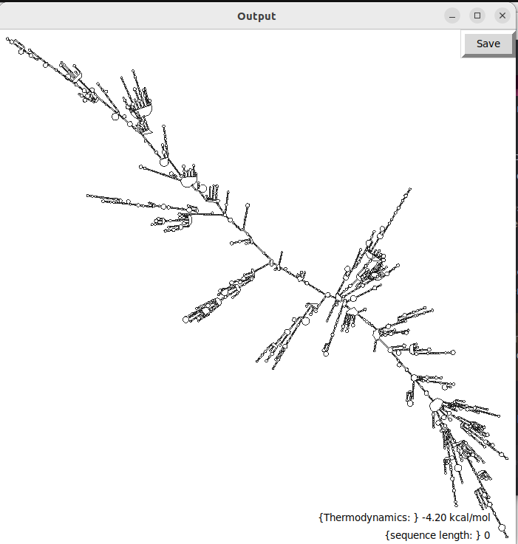

The output for RNAfold can be seen below containing a postscript image output of the secondary structure and a label showing sequence length and minimum free energy. To save the image select the save button in the upper left corner and select where the png image file should be saved.

# RNAalifold

RNAalifold calculates secondary structure for a set of aligned sequences. It takes the aligned file as an input and will output secondary structure predictions along with thermodynamic and sequence information. Select aligned file by browsing and selecting input file, then hit go to execute.

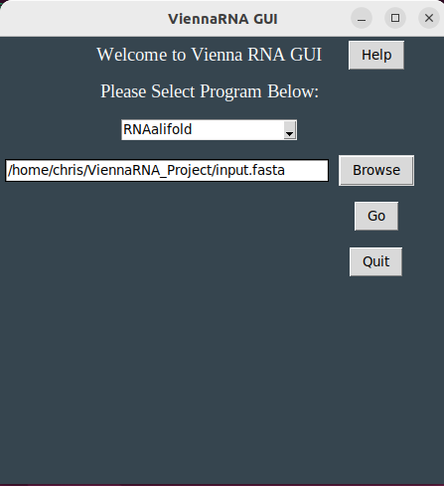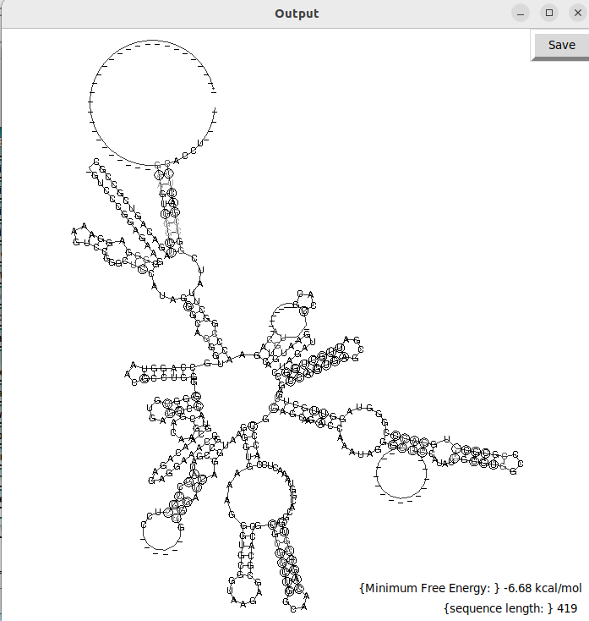

# RNAplfold

RNAplfold calculates the average pair probabilities for local stable secondary structure. The program can be selected from the dropdown menu seen below, and requires either pasting the sequence or by uploading a file containing the sequence of interest. In order to upload a sequence the check box at the bottom of the window must be checked to open a file selection tool and the file can be selected for use. Once either the file is selected or the file pasted select go to execute the program. Make sure to remove any text in the text box if uploading a file.

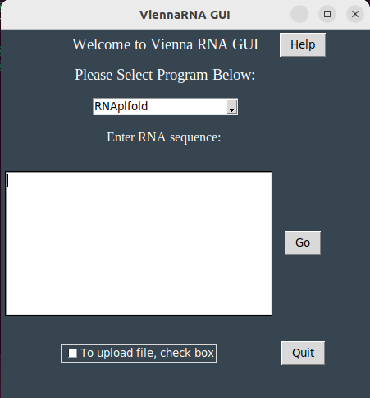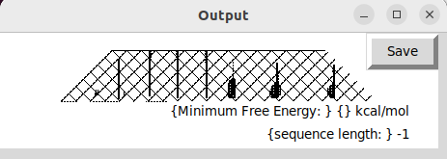

# RNAcofold

RNAcofold calculates secondary structure for two RNA sequences with dimerization . In order to upload a sequence the check box at the bottom of the window must be checked to open a file selection tool and the file can be selected for use. Once either the file is selected or the file pasted select go to execute the program. Make sure to remove any text in the text box if uploading a file.

RNAcofold requires two sequences as an input each sequence is joined by an **&** to indicate the join of each sequence for input.

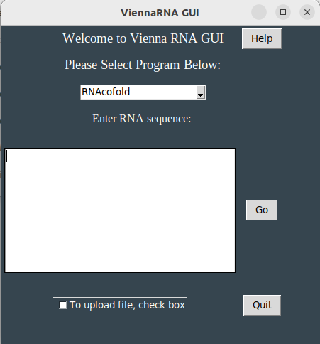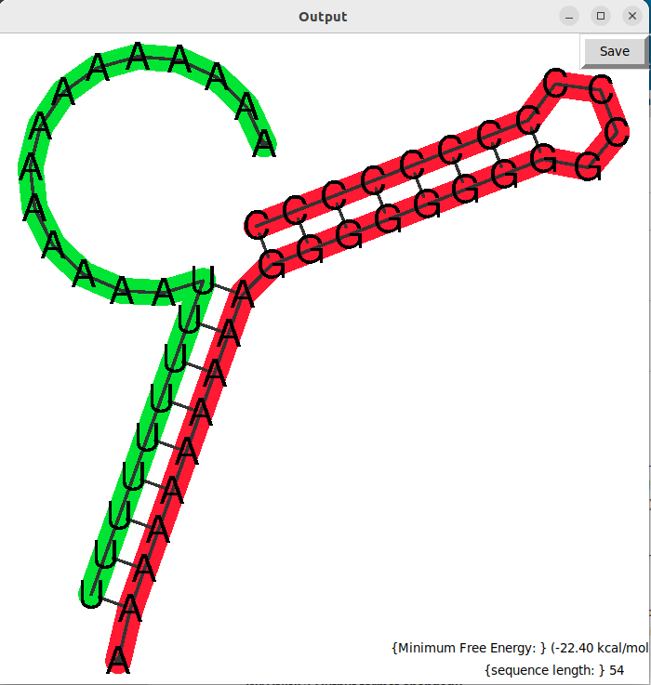

**References**

Lorenz, Ronny and Bernhart, Stephan H. and Höner zu Siederdissen, Christian and Tafer, Hakim and Flamm, Christoph and Stadler, Peter F. and Hofacker, Ivo L. ViennaRNA Package 2.0. Algorithms for Molecular Biology, 6:1 26, 2011, doi:10.1186/1748-7188-6-26

University of Vienna. (n.d.). *The Viennarna package*. Theoretical Biochemistry Group Institute for Theoretical Chemistry. Retrieved March 5, 2023, from https://www.tbi.univie.ac.at/RNA/#